|  |  |
| --- | --- |
|  | |
| epay project  **Deployment and Maintenance Manual**  **V1.0** | |
|  |

|  |
| --- |
|  |

**Contents**

《epay project》 1

Part1 Software inventory and version 3

1、Software inventory 3

Part2 JDK Installation 3

1、JDK Installation 3

2、JDK Configuration 8

3、Test JDK 9

Part 3 Oracle 11g database Installation 10

1 the database software installation 10

2、Database instance configuration 18

3、Database listener configuration 26

4、Test whether database is normal 32

Part4 Bank server installation and deployment 33

1 The bank server installation 33

# Part1 Software Inventory and Version

## 1. Software inventory

### 1.1. Runtime Environment JDK 1.6 and above

### 1.2. Oracle 11g Database

### 1.3. Bank server program

# Part2 JDK Installation

## JDK Installation

Double-click the downloaded executable file jdk-7u3-windows-x64.exe, pops up JDK installation wizard

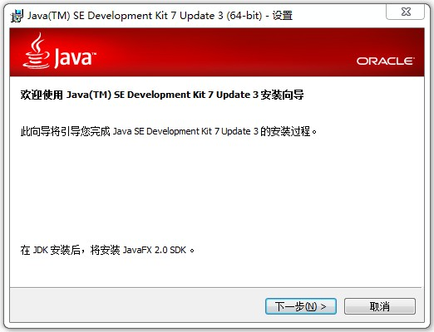

Pop-up software installation path which can be modified, click "Next" to continue

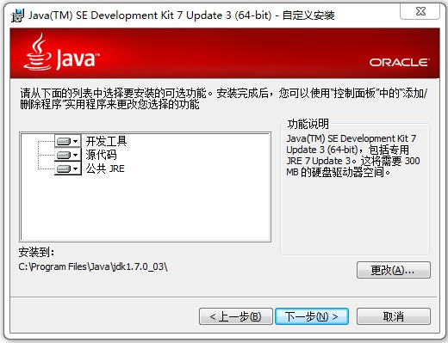

Click "Next" to continue the installation

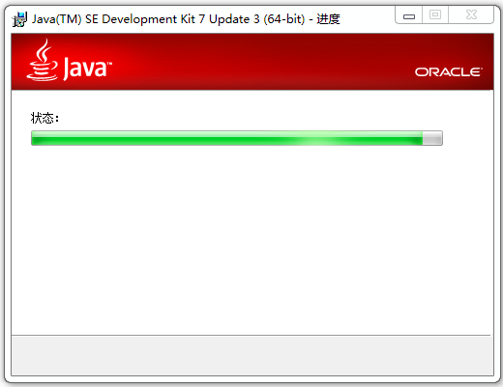

Pop JRE installation directory which can be modified, click "Next" to continue

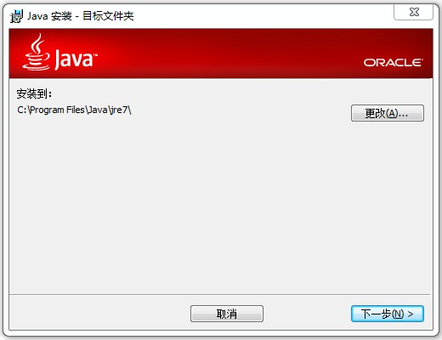

Begin JDK Installation

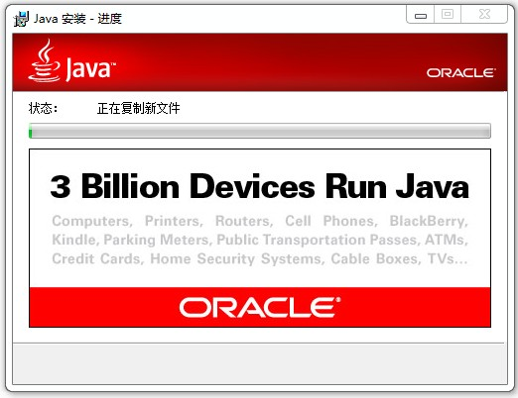

Tip JDK installation is successful, click "Continue"

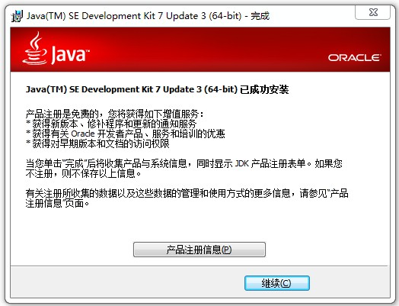

Prompts to install the JavaFX SDK, click "Next" to continue

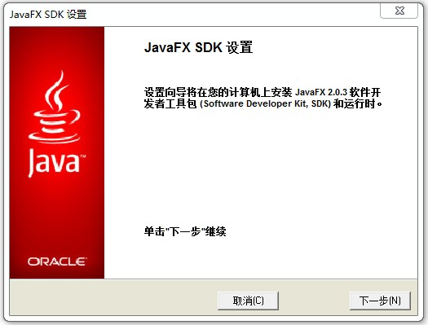

Users can modify the JavaFX SDK installation directory, click "Next" to continue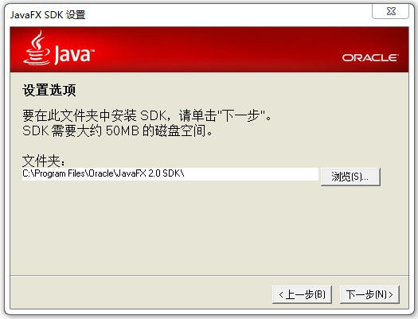

Begin installing JavaFX SDK

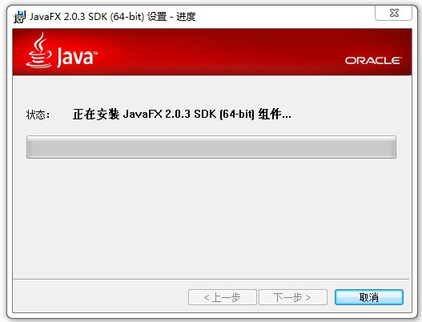

Finally pop JavaFX SDK interface, indicate that setup is complete. Click the close button to complete the installation process

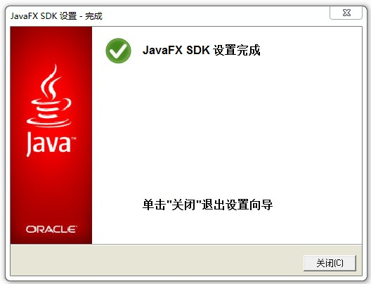

## JDK Configuration

Configuring environment variables:

My Computer -> Properties -> Advanced -> Environment Variables, New variable in the user environment variables, you can also create a new variable in the System Variables

Set the JAVA_HOME environment variable: C: \ Program Files \ Java \ jdk1.7.0_03, as shown:

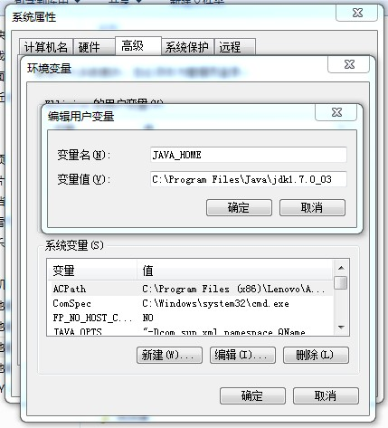

After input is complete, click "OK" button to complete the configuration of the JDK

## 3. Test JDK

In the Start menu, click Run, type ‘cmd’, and click the "OK" button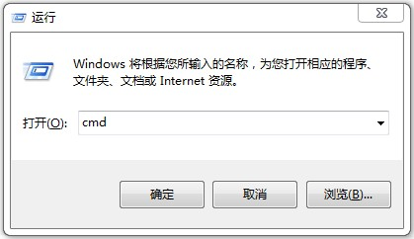

In the CMD mode, enter java-version, see the following figure, indicating JDK installation configuration is successful

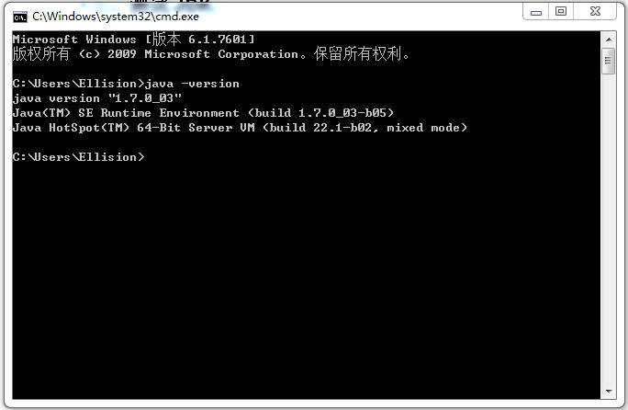

# Part 3 Oracle 11g database Installation

## Database software installation

Select setup.exe and double click it to setup.

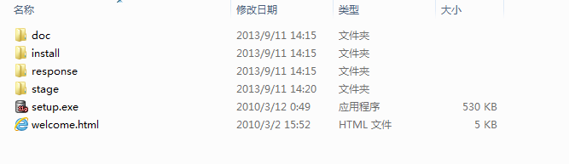

Oracle Database 11g installation interface appears.

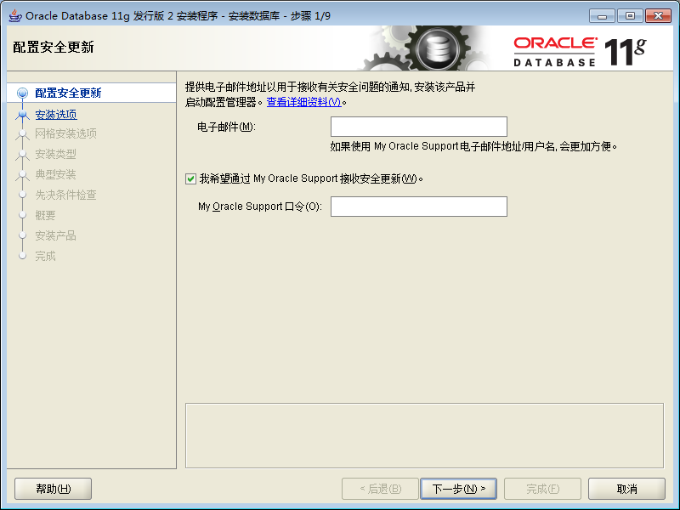

Select Create and configure the database, click Next

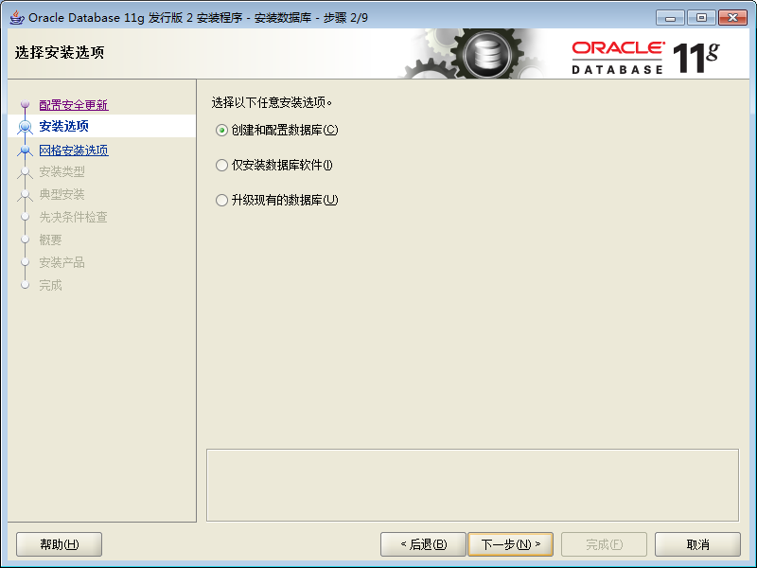

Select the desktop category, click Next

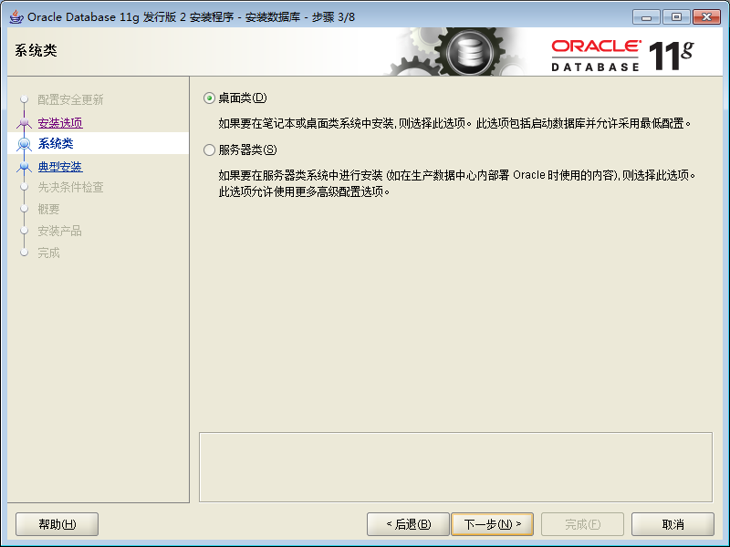

Specifies the Oracle Database 11g home directory, you can select the "Browse" button to make changes. Select Standard Edition, select the character set UTF8. Setting the global database name and administrative password. Click "Next" to continue

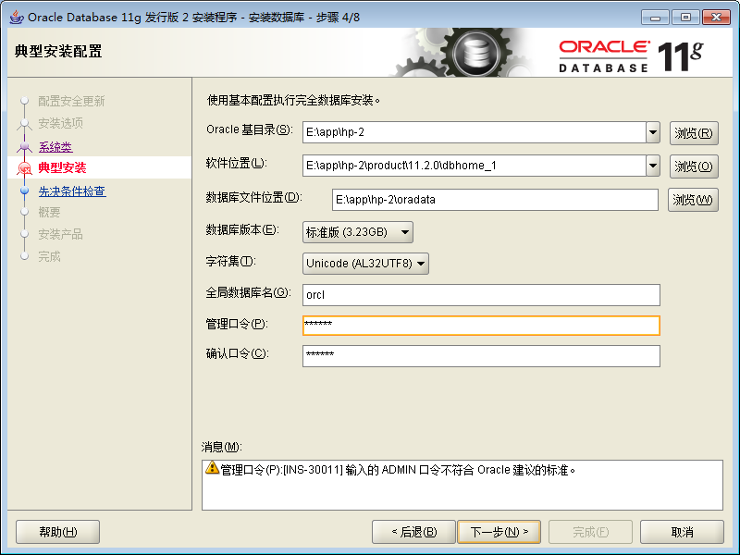

Check Prerequisites

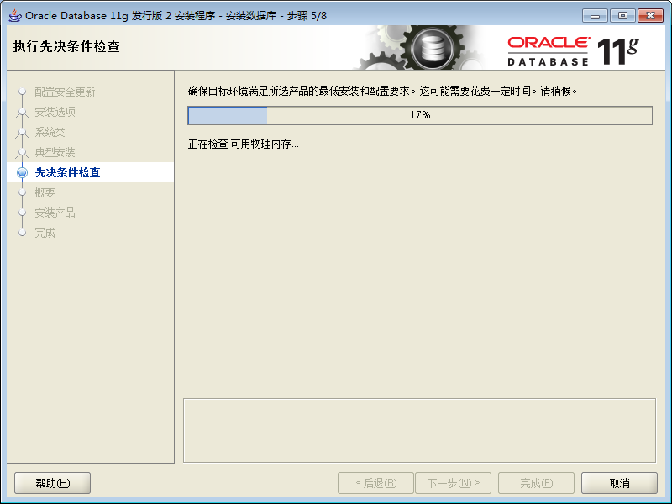

Click Finish to install

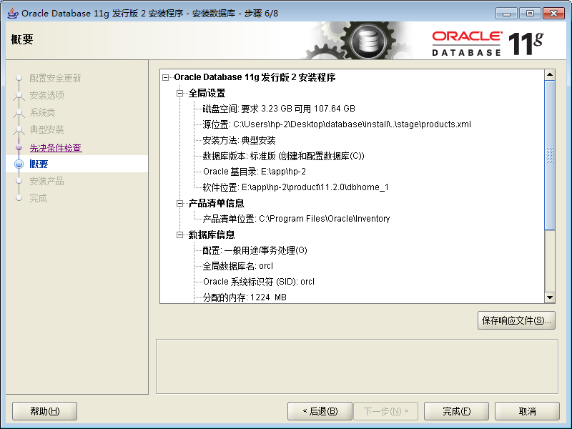

Installing

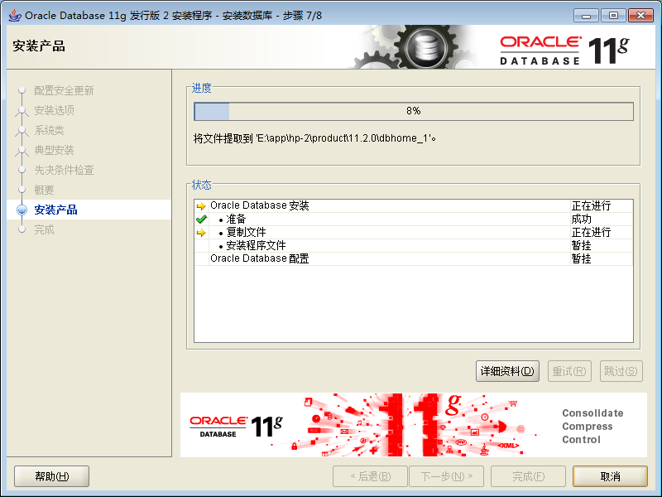

Database creating

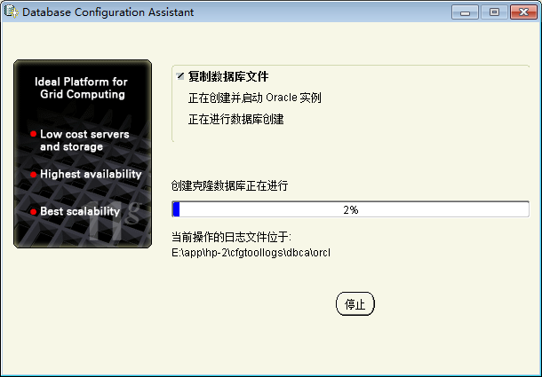

Complete database creation

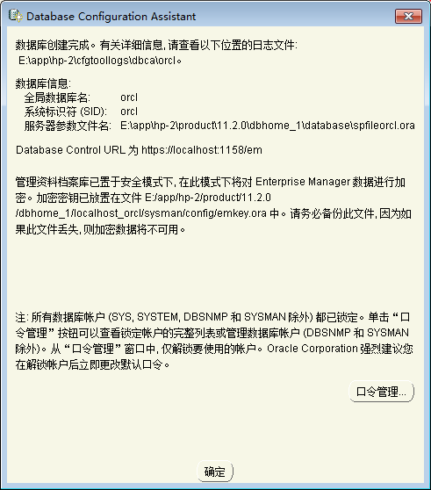

Click Close to complete the installation of Oracle Database 11g database

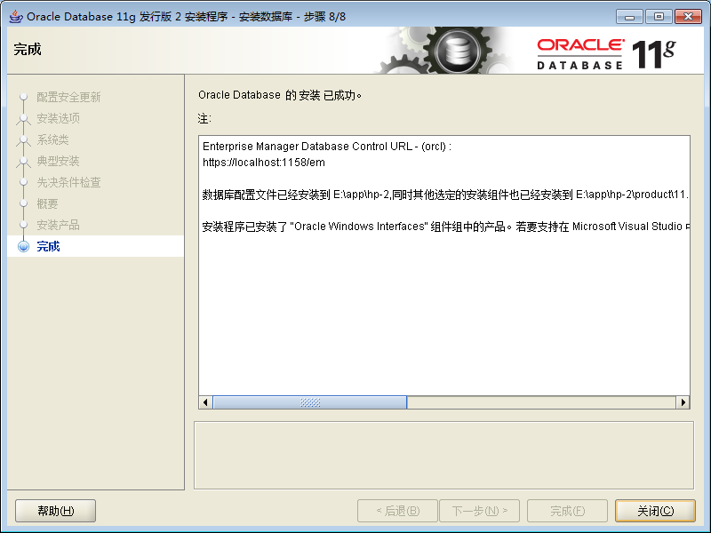

### 2、Database instance configuration

In the Start menu, select the Oracle Database Configuration Assistant program (Database Configuration Assistant) for the database instance configuration, as shown below:

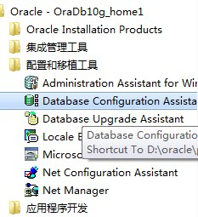

Pop Database Configuration Assistant Welcome screen, as shown below：

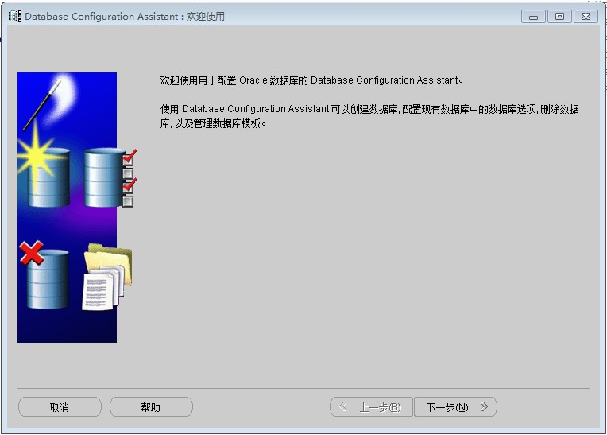

Select "Create Database", click "Next" to continue

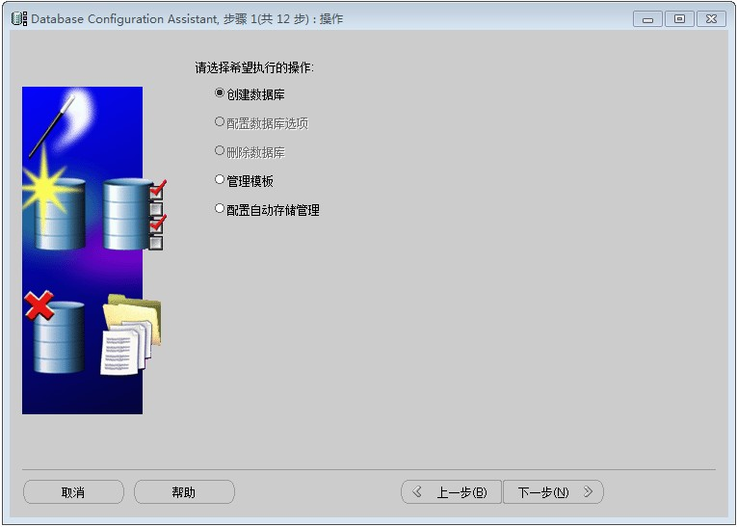

Select the "general purpose" template to create the database, click "Next" to continue

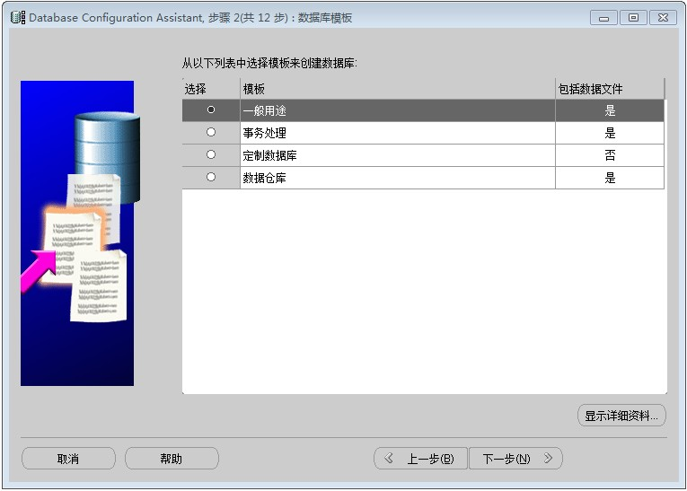

Enter the global database name mrdb, click "Next" to continue

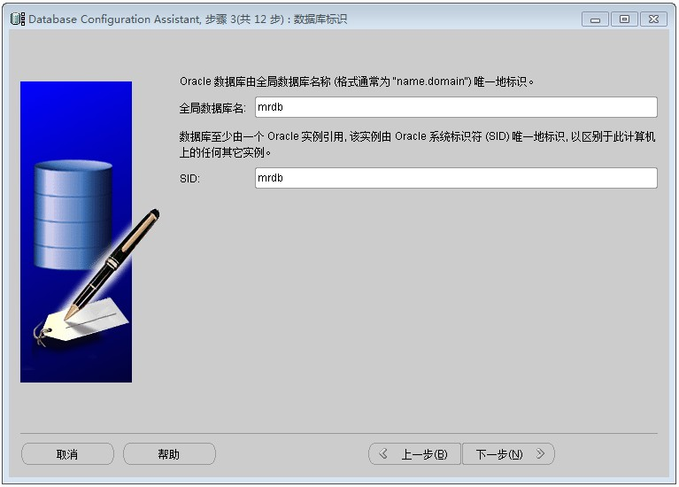

Remove EM option, this installation does not configure Enterprise Manager, click "Next" to continue

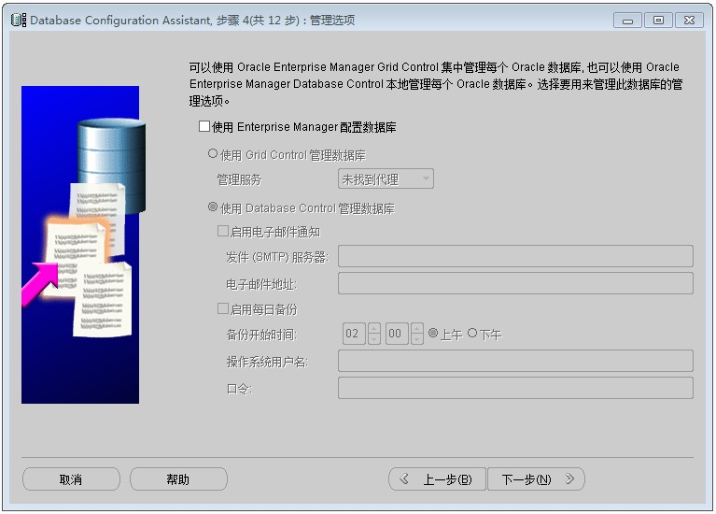

Enter the Oracle database account password, click "Next" to continue

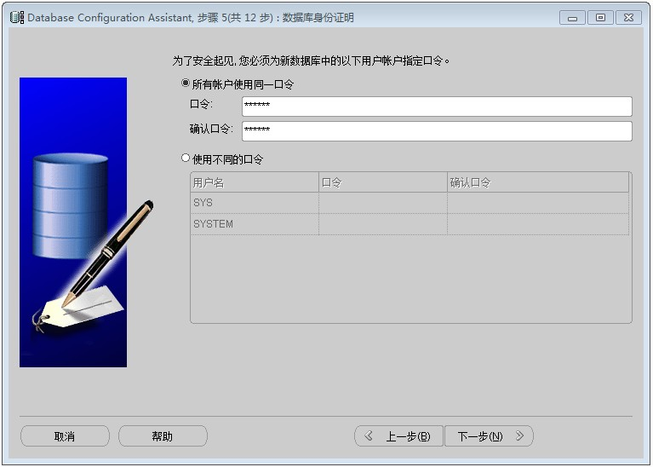

Choose to use the "File System" as a database storage mechanism, click "Next" to continue

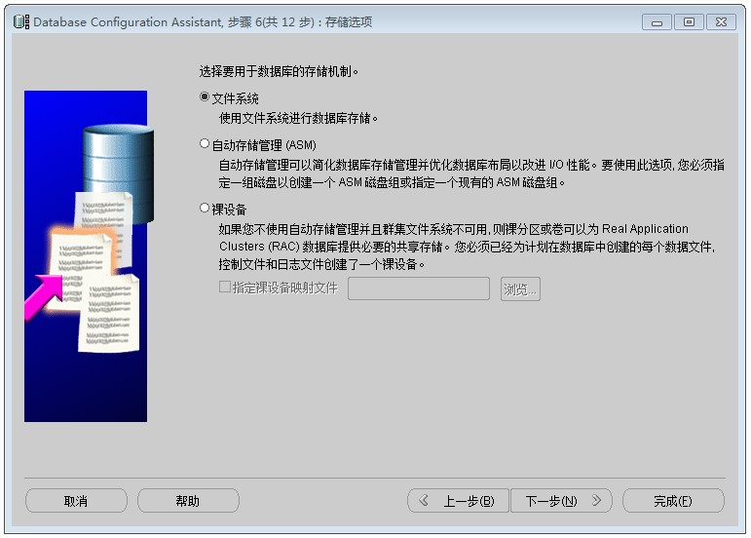

Select the default option, and click "Next" to continue

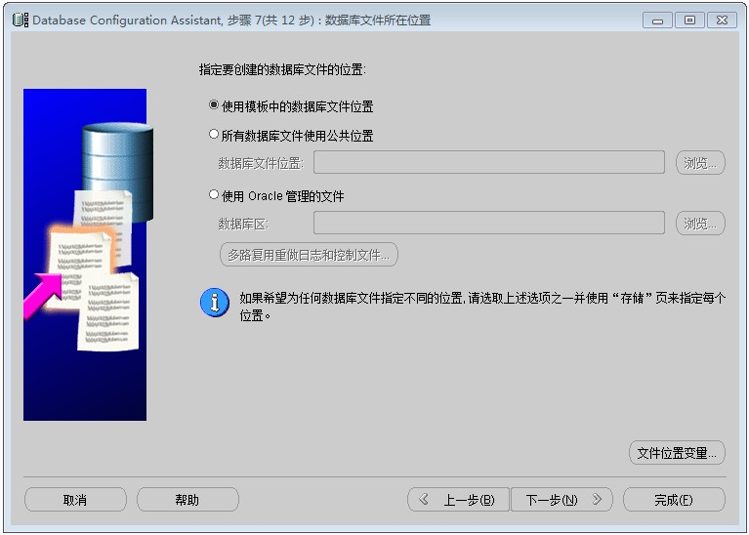

Remove the "Specify Flash Recovery Area" and "Enable archiving" option, where you do not configure the flash recovery area and data archiving, click "Next" to continue

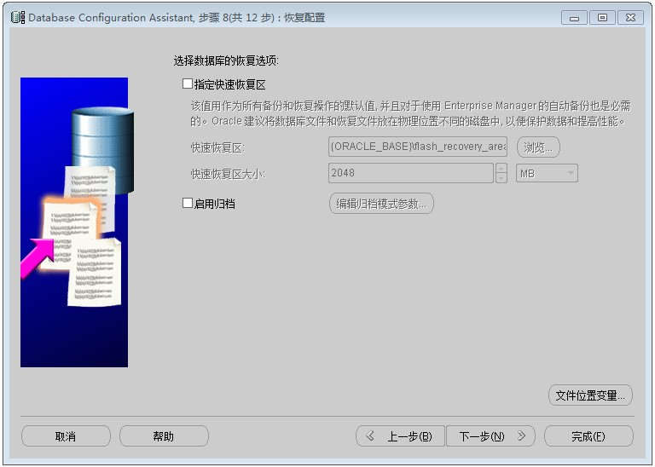

Remove the "sample program" option, click "Next" to continue

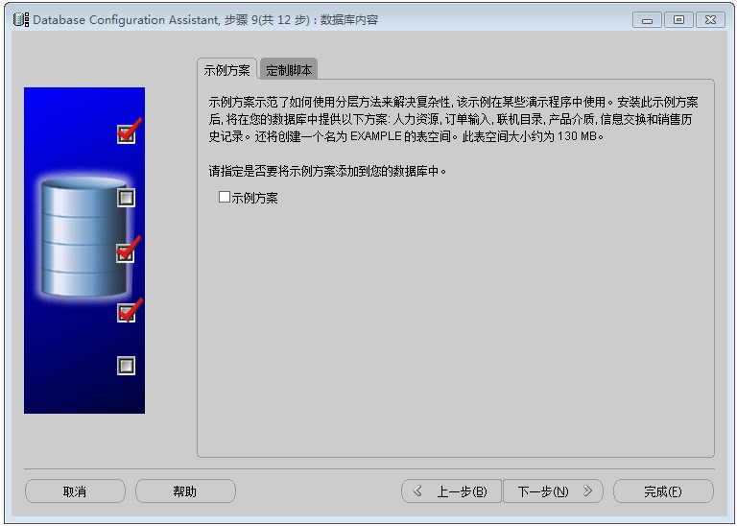

Default database initialization parameters, click "Next" to continue

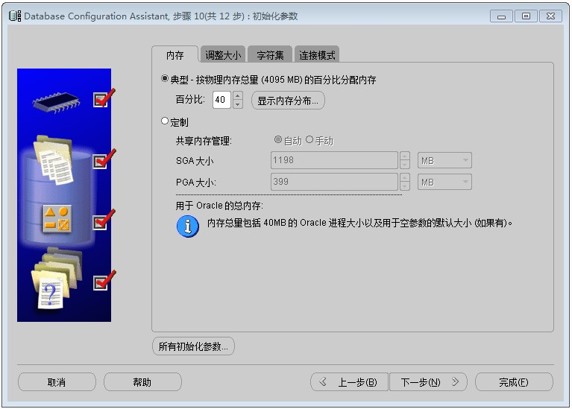

Database configuration information, check the complete, click "Finish" to continue

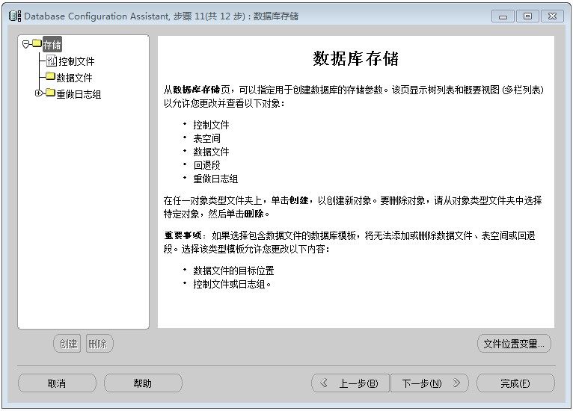

This step does not create a database template, nor generate the database creation script, click "Finish" to continue

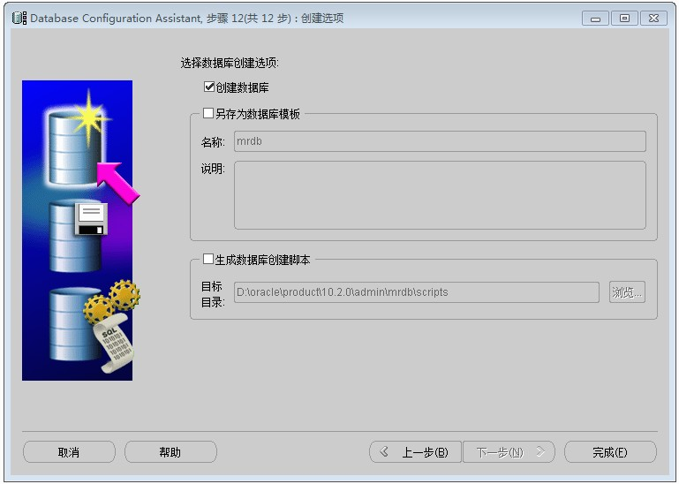

Confirmation dialog box, check and correct and click "OK" to install the database instance

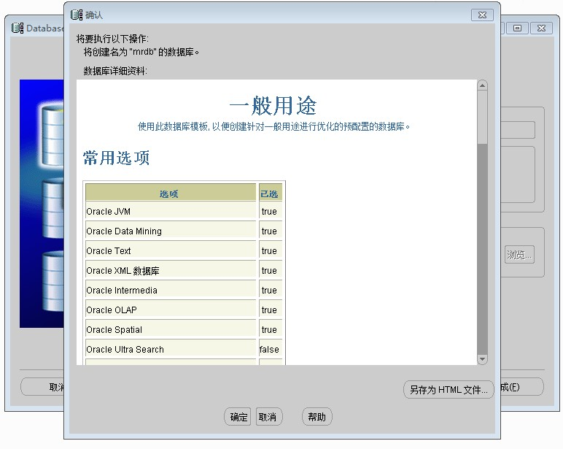

Database instance during the installation.

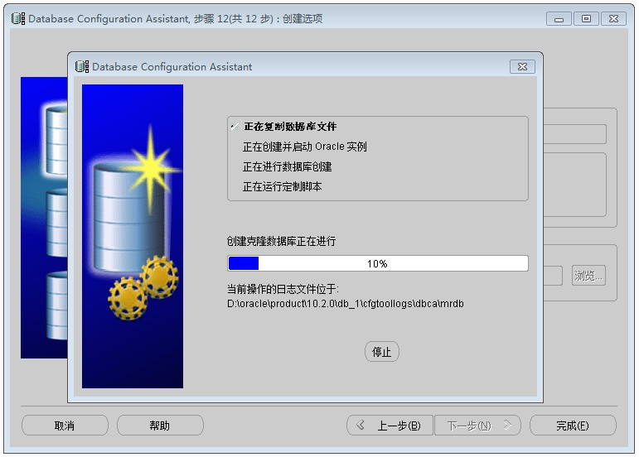

After installation is complete, the database instance can be password changes, click "Exit" to complete the installation.

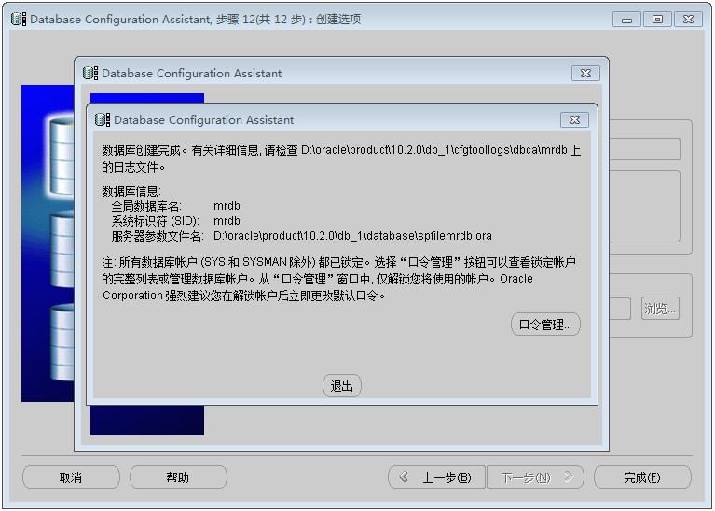

### 3、Database listener configuration

In the Start menu, select the Oracle Net Configuration Assistant Program (Network Configuration Assistant) for the database listener configuration, as shown below:

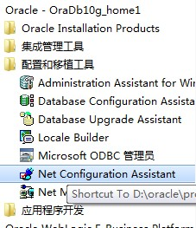

Pop Network Configuration Assistant Welcome screen, select "Listener Configuration" option, click "Next" to continue

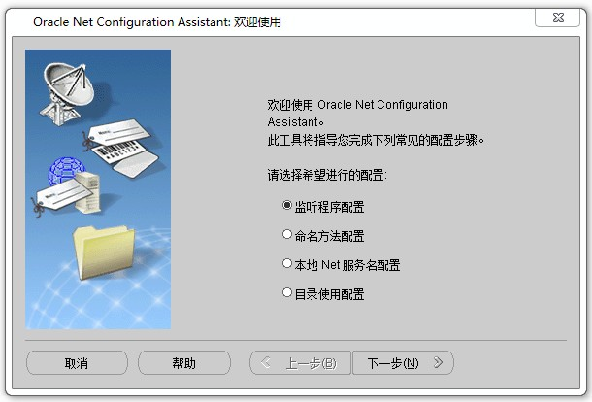

Select "Add" selection, click "Next" to continue

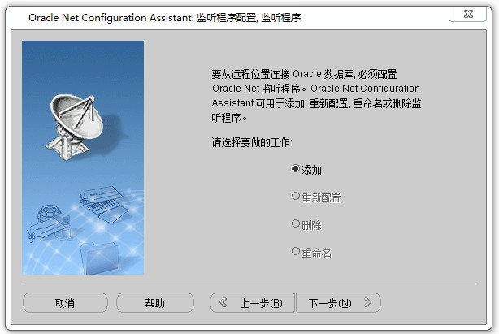

Use the default listener name, click "Next" to continue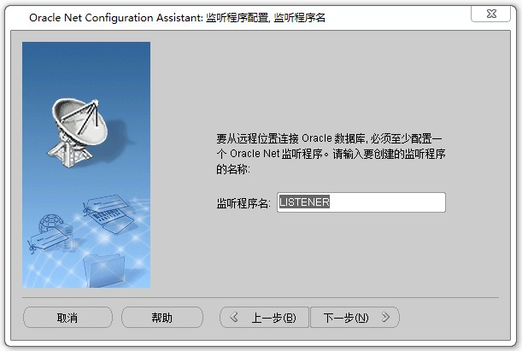

Select the TCP protocol, click "Next" to continue

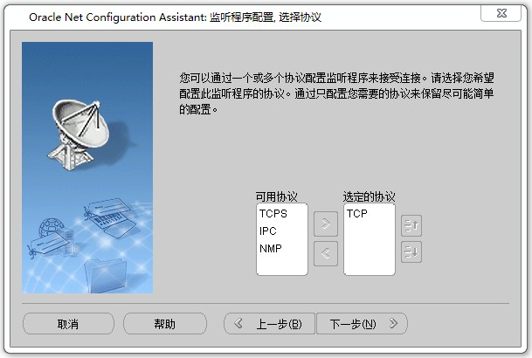

Use the default port 1521, click "Next" to continue

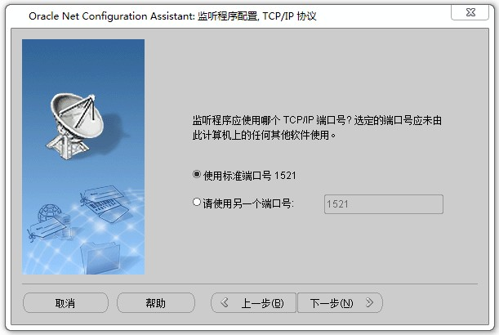

Complete the listener's configuration, click "Next" to continue

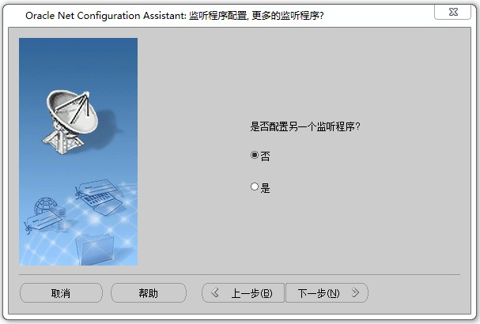

Click the "Allow Access" button

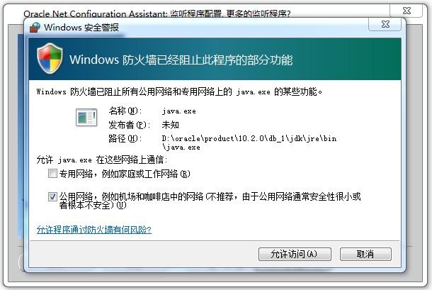

Pop listener interface configuration is complete, click "Next" to continue

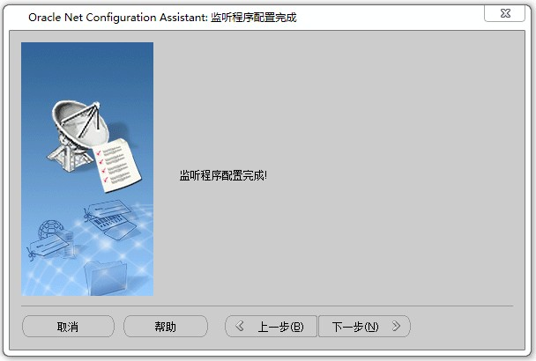

Click "Finish" to complete the configuration of the listener

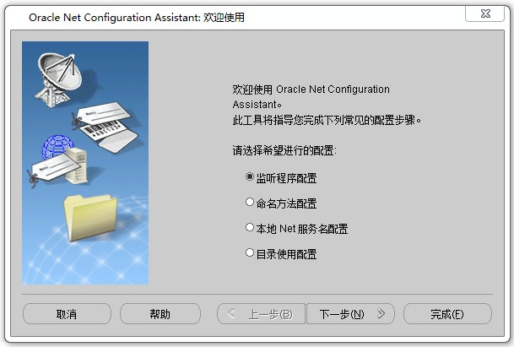

### 4、Test whether database is normal or not

Start Run, type cmd, and click OK

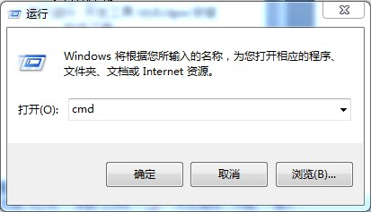

Enter sqlplus system / oracle, as shown below：

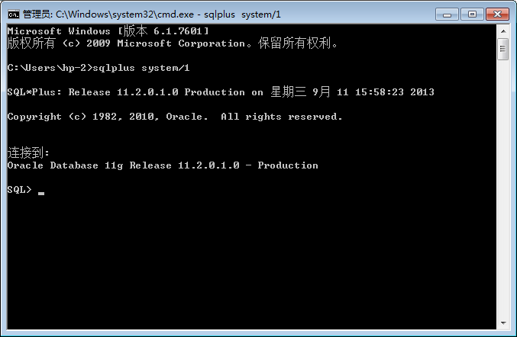

Input select sysdate from dual; tested query the system time, the results identify the Oracle Database installed successfully normal

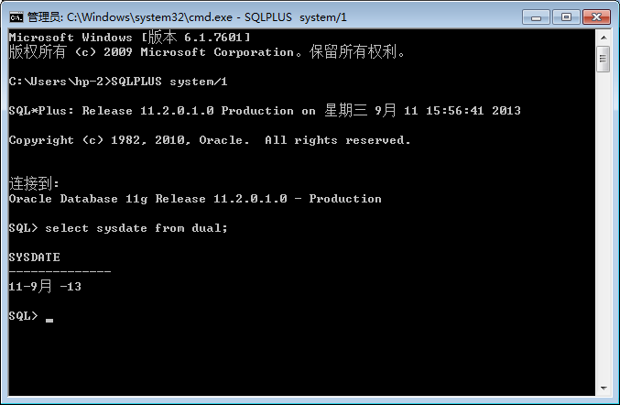

Part4 Bank server installation and deployment

### The bank server installation

Double-click the program icon bank server, run the service program

